The Grafana Dashboard can be accessed from the below given URL.

<http://35.247.196.89:31898/>

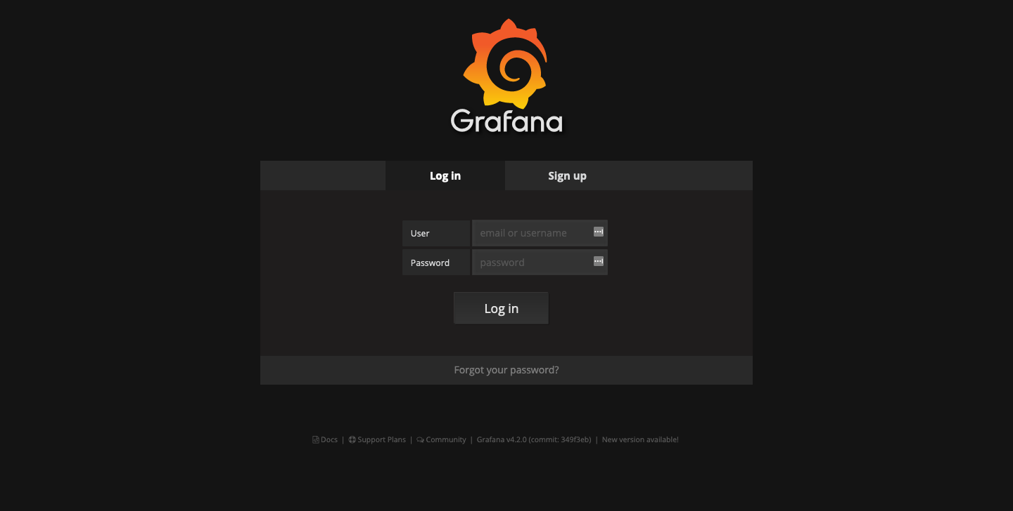

Login to the Grafana Dashboard with the below credentials.

Username : admin

Password : admin

**2. Goto Home > kubernetes Pod Resources**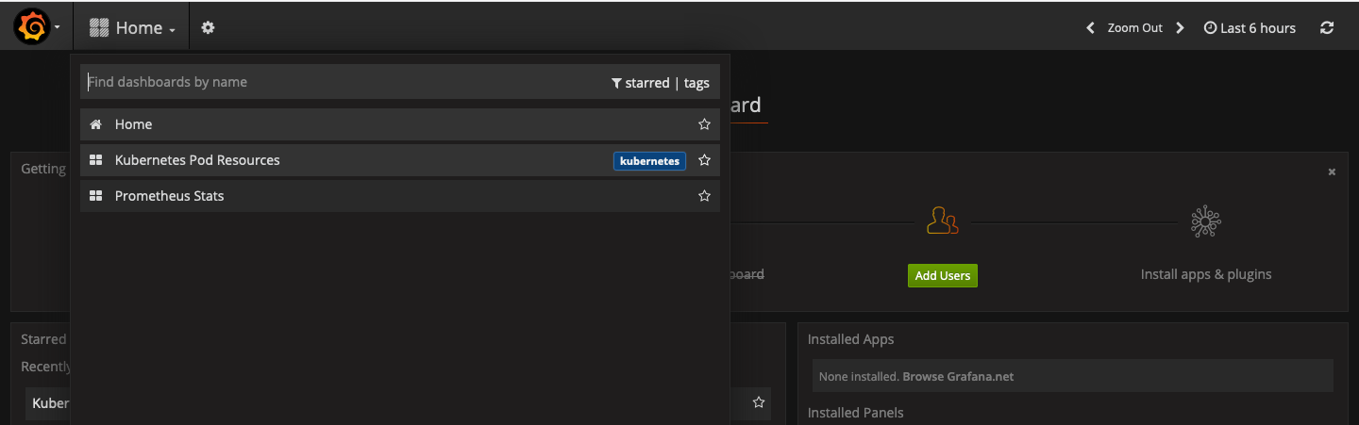

**3. From the Namespace dropdown list select your Namespace**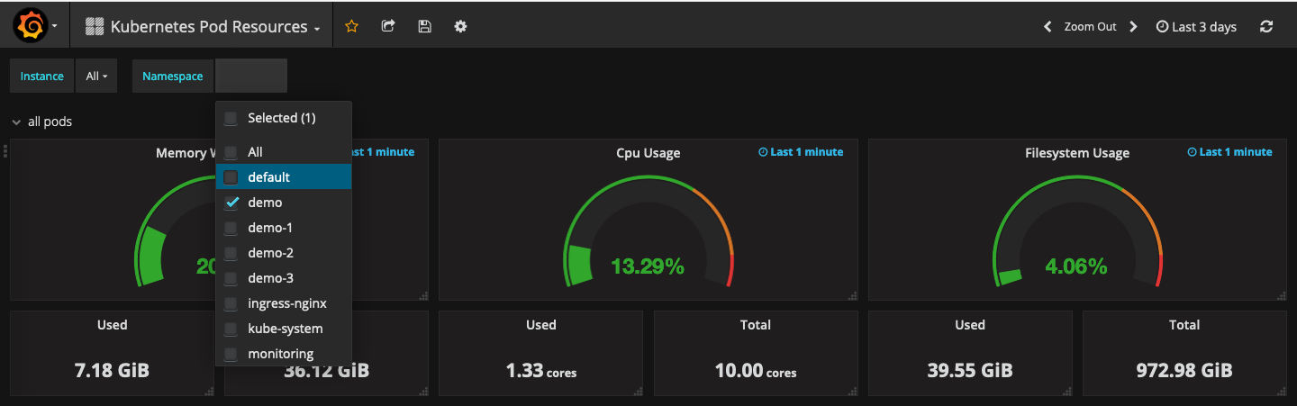

**4. Observe the overall performance and resource utilization of your PODS in your Namespace**

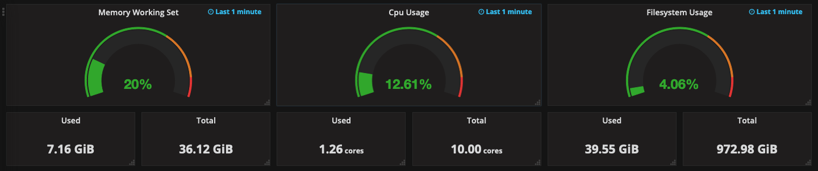

**5. Observe the Memory Working Sets of your PODS**

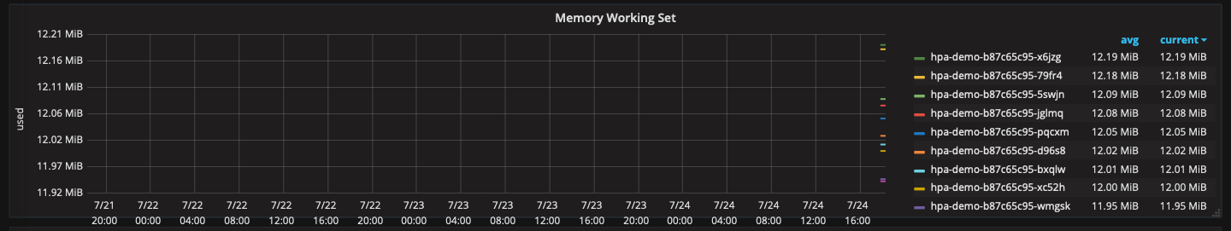**Scroll down on the right to check all the pods deployed in your NameSpace.**

**Similarly you can observe the Network and Filesystem of all the PODs in your Namespace.**

**6. Save your Dashboard by clicking on the settings button and select Save As**

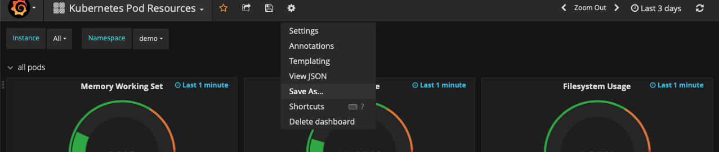

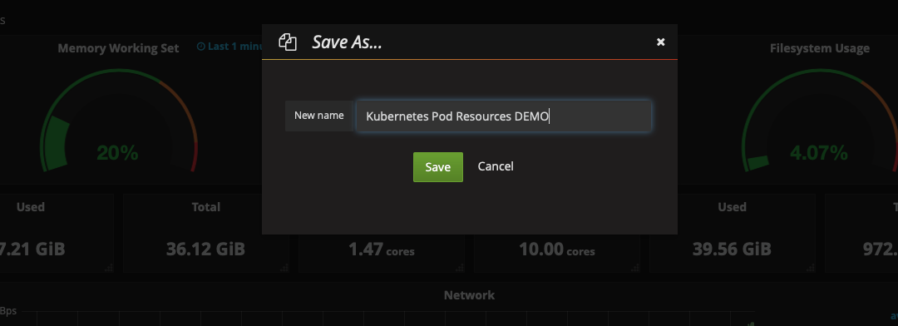

**7. Scroll Down and Click on ADD ROW and Select the Graph option**



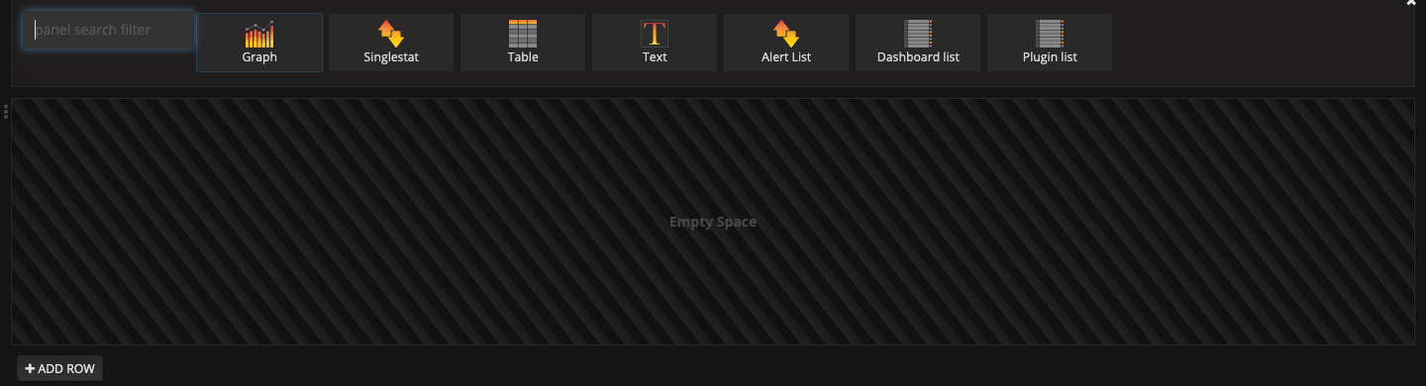

**8. Click on Edit**

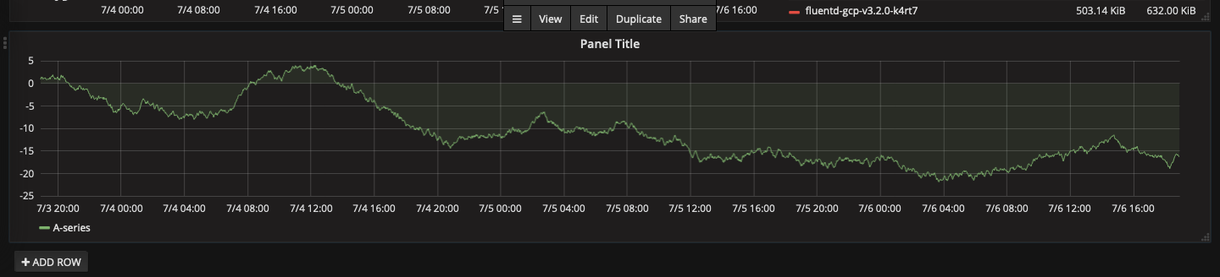

**9. Select the Panel data source as Prometheus** 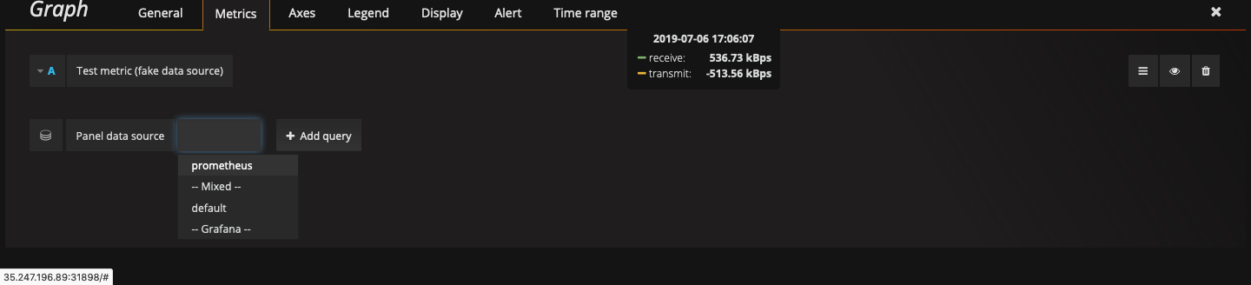

**10. And add the below query updating <your-name> with your name as shown in the following screenshot.**

|  |
| --- |
| **Sum (container_last_seen{name=~"^k8s_hpa-<your-name>.*",namespace="<your-name>"}) by (pod_name)** |

**11. Input Legend format as {{ pod_name }} (including the braces)**

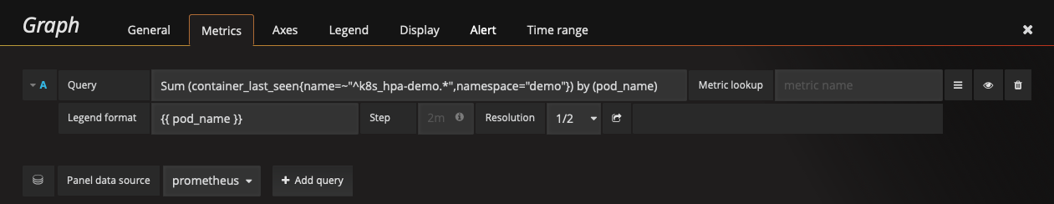

**12. Click on General and Update the Panel Name to Your_Name_HPA**

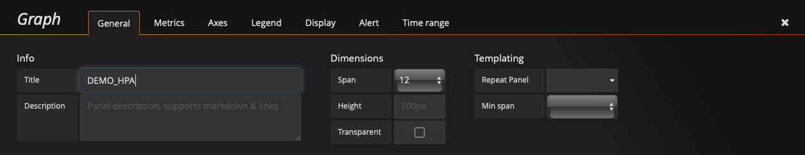

**Click on the ‘X’ button to save and exit.**

**13. Press ( Ctrl + S ) to save the Panel Created.**